**Project Design Phase-I**

**Data Flow Diagram & User Stories**

|  |  |
| --- | --- |
| Project Name | FetalAI: USING MACHINE LEARNING TO  PREDICT AND MONITOR FETAL HEALTH |
| Maximum Marks | 4 Marks |



**Flow:**

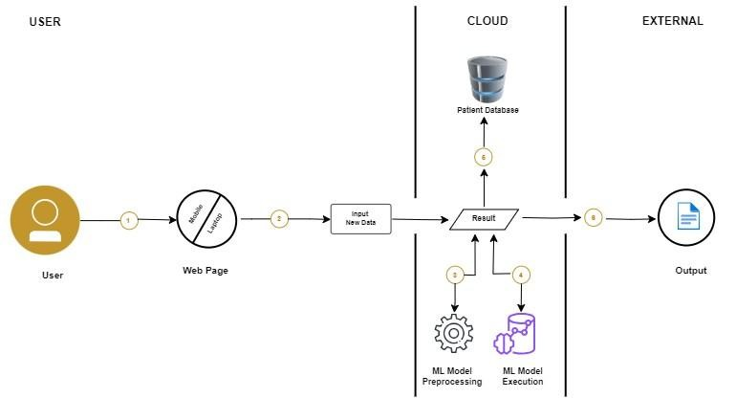

1. User Access the webpage using either mobile phone or system
2. User Enter New Data points for prediction

3 & 4 ML model pre-process and execute the new data and provide prediction result

1. The result is saved into Patient Database
2. The prediction result shown on the screen as output



**Data Flow Diagram (DFD):**

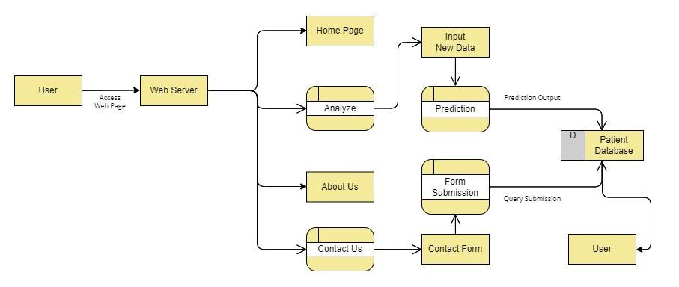

**User Stories**

|  |  |  |  |  |  |  |
| --- | --- | --- | --- | --- | --- | --- |
| **User Type** | **Functional**  **Requirement**  **(Epic)** | **User**  **Story**  **Number** | **User Story/Task** | **Acceptance**  **Criteria** | **Priority** | **Release** |
| User  (Mobile user) | Webpage | USN-1 | Analyse/Predict for new data | All fields should be filled & numeric | High | Sprint-1 |
|  |  | USN-2 | User get Predicted output | Must be of classes (Normal,  Pathological &  Suspect) | High | Sprint -1 |
|  |  | USN-3 | User missed a field area in analyse | Empty Field | Medium | Sprint-2 |
|  |  | USN-4 | User go to About page | Go to About Page | Low | Sprint-3 |
|  |  | USN-5 | User go to Contact Us page | Fill the form | Low | Sprint-3 |
| User  (Laptop/  Desktop  User) | Webpage | USN-1 | Analyse/Predict for new data | All fields should be filled & numeric | High | Sprint-1 |
|  |  | USN-2 | User get Predicted output | Must be of classes (Normal,  Pathological &  Suspect) | High | Sprint -1 |
|  |  | USN-3 | User missed a field area in analyse | Empty Field | Medium | Sprint-2 |
|  |  | USN-4 | User go to About page | Go to About Page | Low | Sprint-3 |
|  |  | USN-5 | User go to Contact Us page | Fill the form | Low | Sprint-3 |